*“Heaven’s Light is Our Guide”*



Rajshahi University of Engineering & Technology

Department of Computer Science & Engineering

Lab Report – 01

Course Code: CSE-3206

Course Title: Software Engineering Sessional

Date:31/12/2024

|  |  |
| --- | --- |
| Submitted By-  Name: Kapil Deb Barman  Department: CSE  Roll No.: 2003181  Section: C | Submitted To-  Farjana Parvin  Lecturer, Dept of CSE, RUET. |

Task: Github repository creation and pushing code form local

Machine.

Introduction:

This lab aims to provide a clear understanding of how to install and configure Git, create a local repository, and upload it to a GitHub repository. It covers the foundational steps of setting up Git, creating and managing repositories, and utilizing Git commands to track, commit and push changes eﬀectively to GitHub.

Git: Git is a free and open-source distributed version control system designed to handle everything from small to very large projects with speed and efficiency.

GitHub: GitHub is a platform that allows developers to create, store, manage, and share their code. It is a popular tool for collaboration on coding projects and is often used by students to work on open-source projects.

Requirements:

1. Git

2. VsCode

3. GitHub Account

Procedure:

Here is the procedure to do the task:

Step-1: Installa,on of Git

1. Download Git

2. Install Git

Step 2: Create a GitHub Repository

1.Go to [GitHub](https://github.com) and log in.

2. Click the **“+”** in the top-right corner, then select **New repository**.

3. Fill in the repository name, description (optional), and set visibility (Public/Private).

4. Check **Add a README file** (optional).

5. Click **Create repository**.

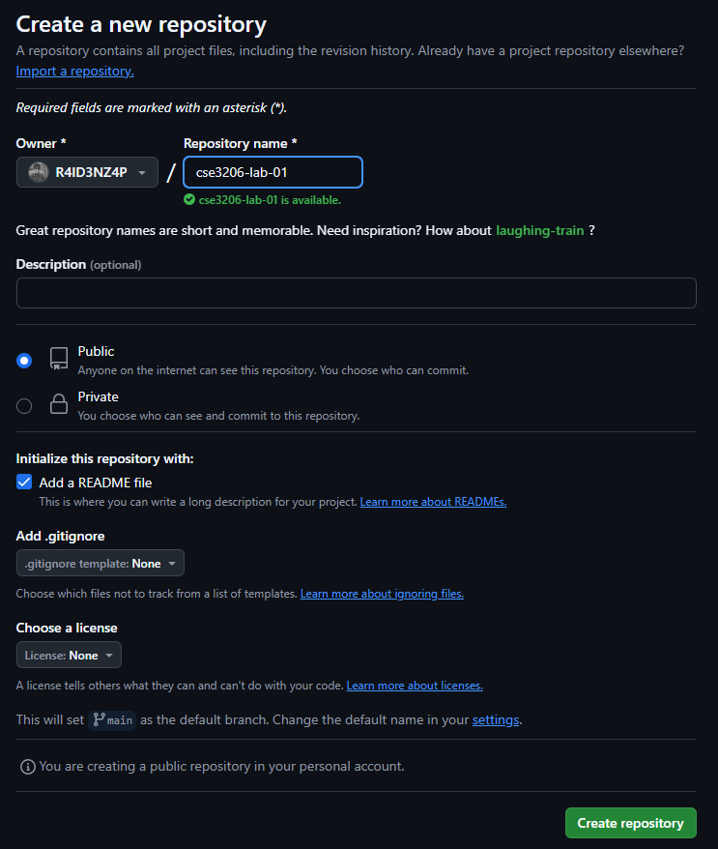

Step 3: Initialize Git Locally

1. Open a terminal on your local machine.

2. Navigate to your project folder:

cd /path/to/your/project

3. Initialize Git in your project folder:

git init

Step 4: Connect Local Repo to GitHub

1. Add the remote URL of your GitHub repository:

git remote add origin <https://github.com/your-username/repo-name.git>

Step 5: Stage and Commit Your Code

1. Stage all files:

git add .

2. Commit the changes:

git commit -m "Initial commit"

Step 6: Push Code to GitHub

1. Push your code to the `main` branch:

git branch -M main

git push -u origin main

Step 7: Verify on GitHub

1. Go to your GitHub repository URL to see the uploaded code.

Conclusion: By following these steps, you can create a GitHub repository, connect it to your local machine, and push code effortlessly. This process enables version control and simplifies collaboration on projects."